**Analysing in Excel**

In this lesson, you use the Analyze in Excel feature to open Microsoft Excel, automatically create a connection to the model workspace, and automatically add a PivotTable to the worksheet. The Analyze in Excel feature is meant to provide a quick and easy way to test the efficacy of your model design prior to deploying your model. You do not perform any data analysis in this lesson. The purpose of this lesson is to familiarize you, the model author, with the tools you can use to test your model design.

To complete this lesson, Excel must be installed on the same computer as Visual Studio.

#### **Browsing by using the Internet Sales perspective**

1. Click the **Model** menu, and then click **Analyze in Excel**.
2. In the **Analyze in Excel** dialog box, leave **Current Windows User** selected, then in the **Perspective** drop-down listbox, select **Internet Sales**, and then click **OK**.

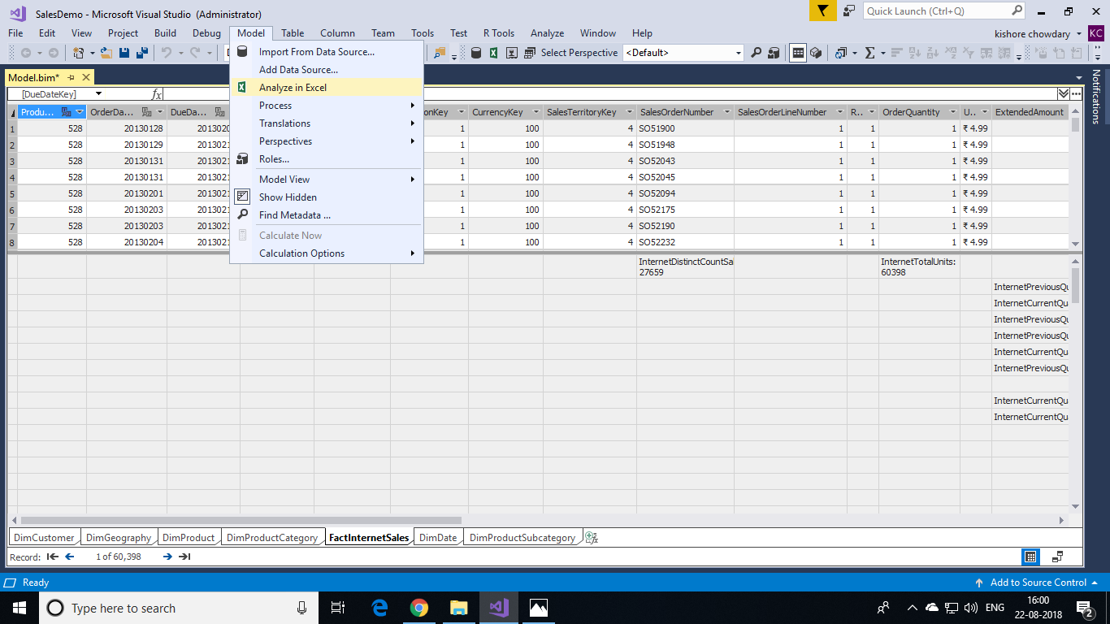

1. In Excel, in **PivotTable Fields**, notice the DimCustomer table is excluded from the field list. This is because of the Perspective that we created previously.

